# Introduction to Functional Interfaces in Java

## Introduction

In this tutorial, we will discuss **Functional Interfaces** in Java. We briefly touched on this topic in the previous tutorial, but here we will explore it in more detail.

## What are Functional Interfaces?

1. Functional interfaces have existed in Java since **JDK 1.0**, previously referred to as \*\***Single Abstract Method (SAM) Interfaces**\*\*.
2. The concept remains the same, but Java 8 introduced \*\***Functional Interfaces**\*\* as a **modernized category**.
3. **Definition**: According to Java documentation, a **Functional Interface** is any interface that has \*\***exactly one abstract method**\*\*.
4. These interfaces are annotated with \*\***@FunctionalInterface**\*\*, introduced in **Java 8**.

## Understanding @FunctionalInterface Annotation

- The **@FunctionalInterface** annotation is optional.

- It helps validate interfaces to ensure they contain only **one** abstract method.

- If an interface is annotated with **@FunctionalInterface** but contains multiple abstract methods, compilation will fail.

- This **annotation enforces** the contract of a functional interface.

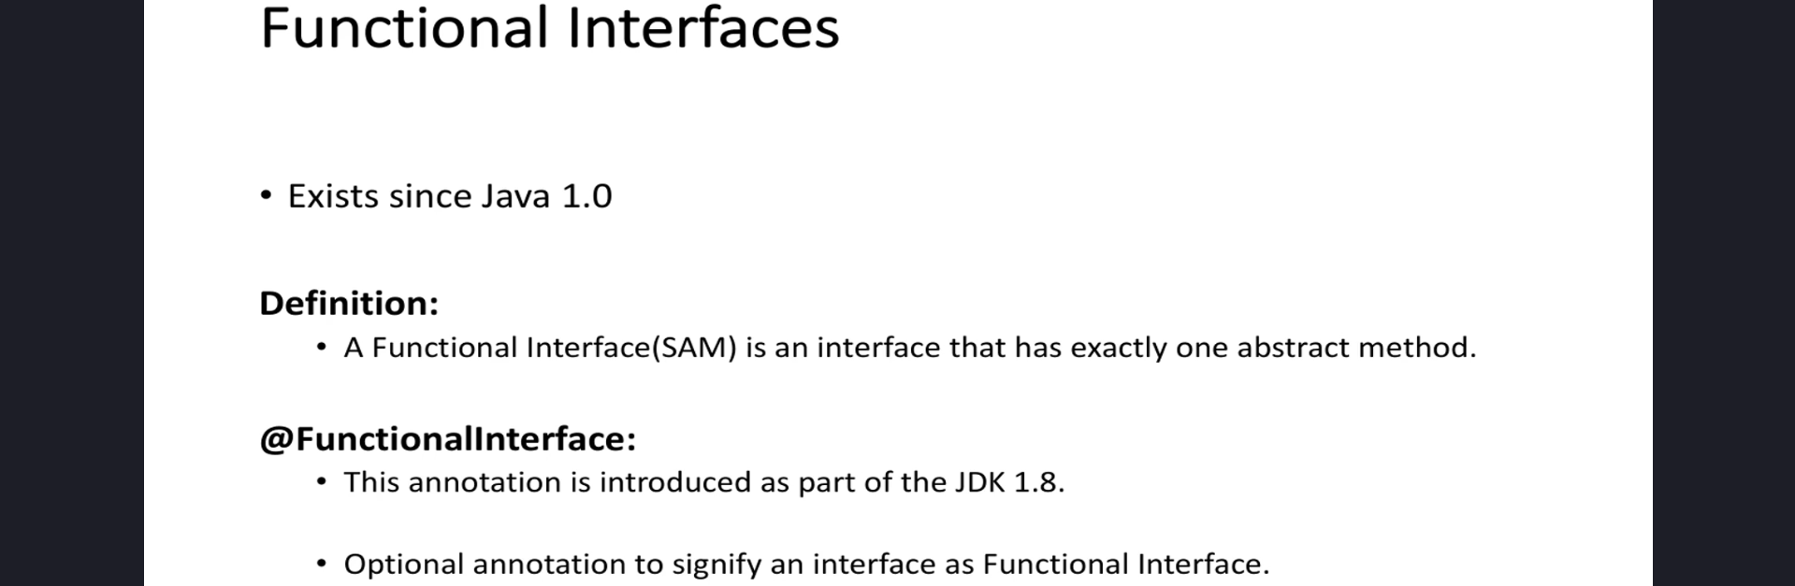

## Functional Interfaces Introduced in Java 8

Java 8 introduced **four primary functional interfaces**:

## 

## Why Should You Learn Functional Interfaces?

- You may not use these interfaces directly in your projects, but they **enhance Java Collections** like **List, Map, and Set**.

- These enhancements make development **faster and more efficient**.

- Java 8 introduced several **functional programming concepts** that rely on these interfaces.

- Mastering these concepts will improve your ability to write **concise and readable** Java code.

## What’s Next?

- If this information seems overwhelming, don’t worry!

- Upcoming tutorials will include **coding examples** to explain each of these interfaces in detail.

- We will cover how to use these interfaces effectively in **real-world Java applications**.

## Conclusion

- Functional Interfaces are a **key feature** introduced in **Java 8** to support functional programming.

- They provide **concise, reusable, and efficient** ways to work with Java Collections and Streams.

- Understanding these interfaces will help you **write modern Java code more effectively**.

### **End of the Tutorial**

Thank you for watching!